**Project Design Phase**

**Solution Architecture**

|  |  |
| --- | --- |
| Date | 15 February 2025 |
| Team ID |  |
| Project Name |  |
| Maximum Marks | 4 Marks |

Solution Architecture:  
  
This solution architecture focuses on enabling secure, compliant, and efficient data import workflows into ServiceNow. It integrates multiple components including Import Sets, Transform Maps, MID Server, and ACLs to provide a complete and scalable data ingestion solution.

Solution architecture is a complex process – with many sub-processes – that bridges the gap between business problems and technology solutions. Its goals are to:

* Find the best tech solution to solve existing business problems.
* Describe the structure, characteristics, behavior, and other aspects of the software to project stakeholders.
* Define features, development phases, and solution requirements.
* Provide specifications according to which the solution is defined, managed, and delivered.

Example - Solution Architecture Diagram:  
  
Architecture and data flow for secure data import in ServiceNow:  
- External data sources (CSV, APIs, databases)  
- Secure transmission using HTTPS or MID Server  
- Import Sets and Transform Maps for data processing  
- Validation scripts to ensure data integrity  
- ACLs and Encryption to enforce security and access control  
- Monitoring dashboards and audit logs for compliance tracking

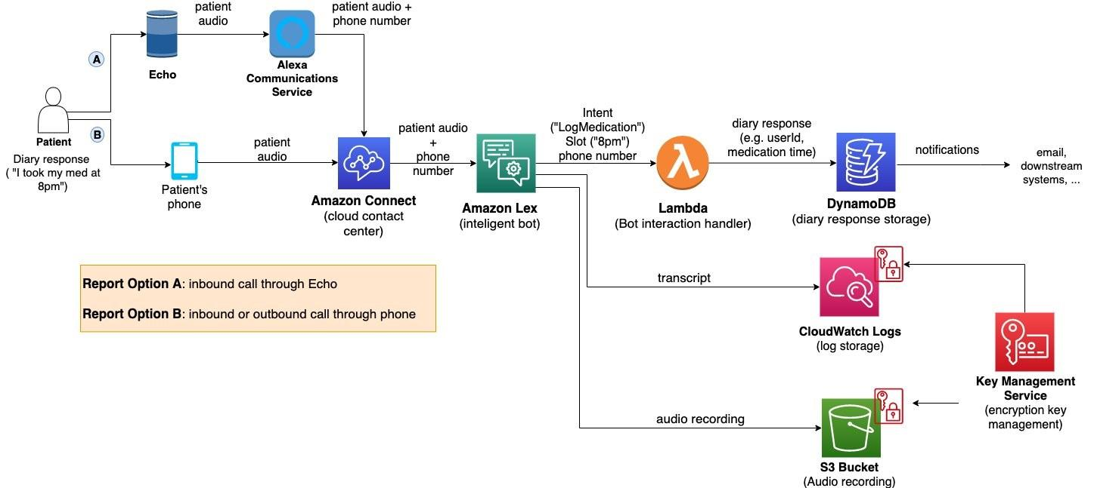

*Figure 1: Architecture and data flow of the voice patient diary sample application*

**Reference:** [**https://aws.amazon.com/blogs/industries/voice-applications-in-clinical-research-powered-by-ai-on-aws-part-1-architecture-and-design-considerations/**](https://aws.amazon.com/blogs/industries/voice-applications-in-clinical-research-powered-by-ai-on-aws-part-1-architecture-and-design-considerations/)